INTEGRATION OF EDMODO – BLENDSPACE – GOOGLE DOCS – WEEBLY

- How to add the Blendspace App on Edmodo
- Synchronising your Google Doc Account
- Integrated Lesson Plan examples
- FREE TIME – add blendspace, synchronise your google docs, submit an assignment

Blendspace – How to add the Blendspace App to Edmodo:

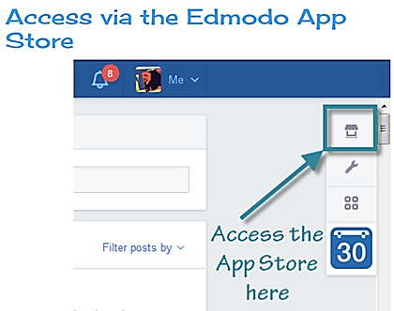
1. Login to your Edmodo account.
2. Click the App Store icon from the toolbar in the top right of your screen.
3. Click on the Blendspace icon found under Top Free Apps
4. Click on the green FREE button
5. Click on the groups you want to install the App
6. Click the ‘I AGREE’ box
7. Click the blue INSTALL button

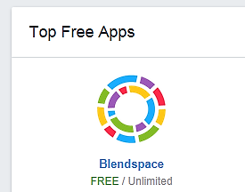

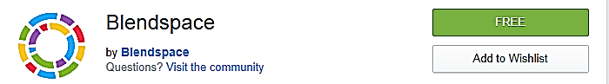

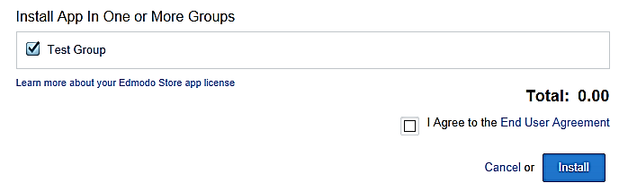

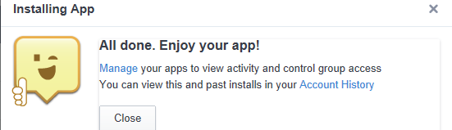

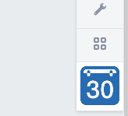
8. Click on the App Launcher icon from the toolbar in the top right of your screen
9. Click on the Blendspace icon which appears
10. Log into your Blendspace account (you should only need to do this once)
11. Place your arrow over the Blendspace lesson you want to share
12. Click SHARE
13. Click on the class you want to share this lesson with.
14. Close this window and the remaining Blendspace home page window
NOTE: Each time you add a new group you will need to install the Blendspace App. This can be done simple by clicking the MANAGE APPS icon which looks like this:

Click on the class you wish to add and then click INSTALL.

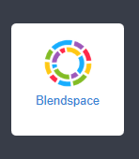

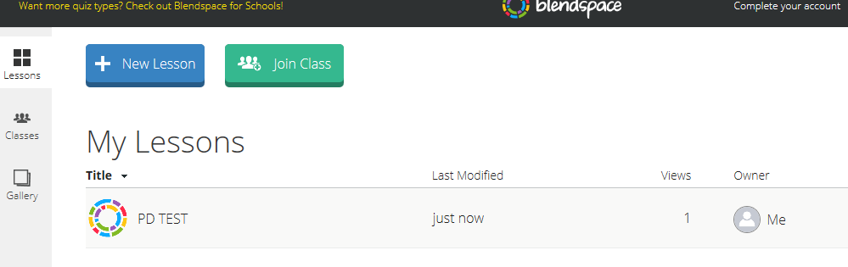

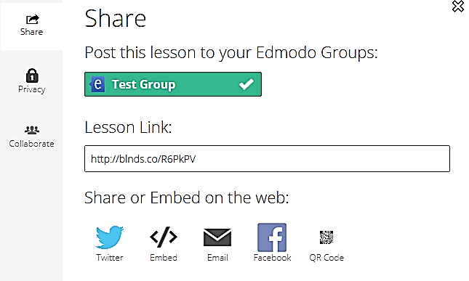

15. You should now have you Edmodo page open. A post should tell you that your lesson has been shared.

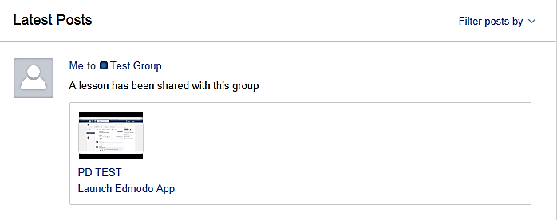
In the past you would have needed to
have copied and pasted the embed
code from Blendspace, logged into
Edmodo, made a post to your class and
attached the embed code as a link.

You should now be able to post your
Blendspace lessons simply by clicking
on the app launcher button.

Google Docs - To link your Google Docs to your Edmodo Library:

1. Login to your Edmodo account.
2. Click the Library icon from the top toolbar.
3. Select the Google Docs link on the left panel.
4. Select the "Connect with Google Docs" button.
5. Sign into your Google Docs account.
6. Select Allow Access when prompted to ask permission.

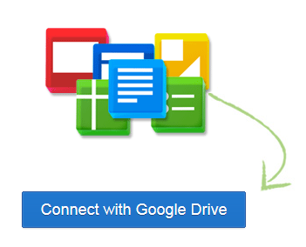
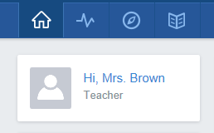
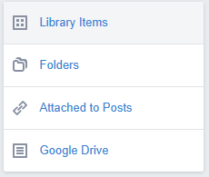

You will now be able to share Google Docs with your groups.
Students will be able to turn in Google Docs as assignments.

Note: It is recommended that all students within your groups link their Google Docs account with Edmodo before you begin sharing Google Docs with those groups/students.

Share Google Docs with your Groups

Once your Google Docs account is linked to your Edmodo Library you can then share your Google Docs in your Edmodo groups. To do this:

1. Type a message in the post bubble.
2. Select “Library” to choose the document you want to attach.
3. Select the “Google Docs” link from the left panel.
4. Select the document you want to share.
5. Set the permissions for the document via the checkbox at the bottom of the page - “Allow users that have connected their Google account to edit.” Note that you must be the owner of the document in order to give others editing privileges.
6. Select “attach”. You will be taken back to the post bubble where you can choose the group/individuals you would like to send the document to. Click “send” to share.

From the Edmodo stream, group members or individuals whom you shared the document with will be able to select the “Open in Google Docs” link to edit the document from their web browser.

Students can also follow the same procedure to turn-in a Google Doc as an assignment.

Setting an Assignment Using Edmodo and Google Docs

1. Click on the Assignment Tab on your Edmodo homepage.
2. Give your Assignment a Title and Due Date
3. Write a description about your assignment.
4. You may like to attach a document which describes the assignment in detail.
5. If attaching an assignment document click the paper clip, browse your documents and upload.
6. Select the class you want to complete this assignment by typing in the Send to box.
7. Click Send
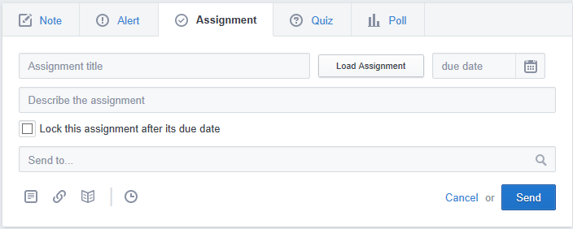

Submitting an Assignment Using Edmodo and Google Docs: (For Students)

1. Log into your Edmodo page.
2. Click on the group for which you have been set an assignment.
3. Read the assignment instructions
4. Open a new window and log into your Google Docs account. Complete your assignment task.
5. Once you have finished your assignment set the sharing permissions to anyone with the link.
6. Close your Google Docs window and return to Edmodo.
7. Click TURN IN
8. Click on the LIBRARY link and then Click Google Drive. (all students should have synchronised)
9. Select the Google Doc you wish to attach. Click the box which states ‘Allow users to Edit’
10. Click the blue POST button.
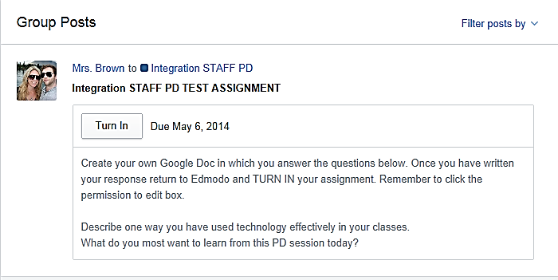

One of the reasons you should submit assignments or essays in this way is that it allows you to manage your documents and record results in a much more efficient way. You can easily add comments to your students’ assignments just as you might using a word document. However, you no longer need to save the document, attach it to an email and send it back to the student! You can quickly see who has not submitted their assignment and record their grade. No messy papers!
INTEGRATED LESSON PLAN: Topic Novel Study

Students complete these tasks in class over the course of one lesson and complete for homework. Answers will be discussed in class the following lesson. Task 3 posters printed and put on the wall.

This lesson integrates the following online tools - Weebly, Edmodo, Google Docs and Weblinks.

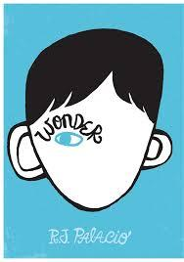
‘WONDER’ - RJ PALACIO BACKGROUND ASSIGNMENT

This background assignment is designed to help with your understanding of the content and issues present in the novel ‘Wonder’ written by RJ Palacio.

Complete the questions and activities below. Write your response to these questions in paragraph format using Google Docs. TURN IN your complete assignment on Edmodo.

TASK 1:

Log into Edmodo and follow the link to my Weebly www.mrsjuliebrown.weebly.com

Under Year 9 Novel click on Wonder. Watch the book trailer and read the background information on the inspiration behind this novel.

- What is the name of the main character and how old is he?
- What is it about the main character that makes him “extraordinary”?
- What exactly is a “craniofacial” abnormality? Explain in your own words.
- What causes these craniofacial abnormalities? Summarise in your own words.
- What are the most common types of craniofacial abnormalities? Summarise.
- What real life incident inspired the author to write ‘Wonder’? Summarise.
- Have you ever experienced a similar situation? How did you react and why?
- The author states that this incident “got me thinking a lot about what it must be like to have to face a world every day that doesn't know how to face you back." Explain in your own words what you think this means.
- Which statement do you think best summarises the main message in this novel?

TASK 2:

Complete a Google image search for “cranciofacial abrnormalities”. Save and insert into your Google doc at least three images. These must be appropriate for school.

TASK 3:

- Search inspirational quotes about accepting difference and being an individual.
- Go to the following website http://www.recitethis.com/ .
- Type the quote you have chosen in the box provided.
- Select a background template.
- Click CREATE and DOWNLOAD your image to your computer.
- Insert your saved image into your Google Doc. Use a new page.

